**Meeting Minutes**

**Date: 5 Oct, 2023 Time: 3:35**

**Project Title: Tweetify**

**Members:**

|  |  |  |
| --- | --- | --- |
| **Registration No** | **Name** | **Attendance/ Remark** |
| **2021-CS-190** | **Abdul Mateen** | **Present** |
| **2021-CS-205** | **Alishba Javeed** | **Present** |

**Type of Meeting: Physical**

**Location: Lab 1, CS Department UET Lahore**

**Agenda:**

* **Figma Design**
* **Database Schema**
* **Database Design**

**Discussion or Feedback**

Discuss the database design and scalability with client. Figma Design reviewed by owner.

**Signature:**

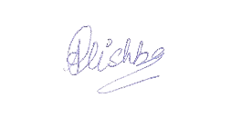

Owner

Alishba Javeed

Developer

Abdul Mateen